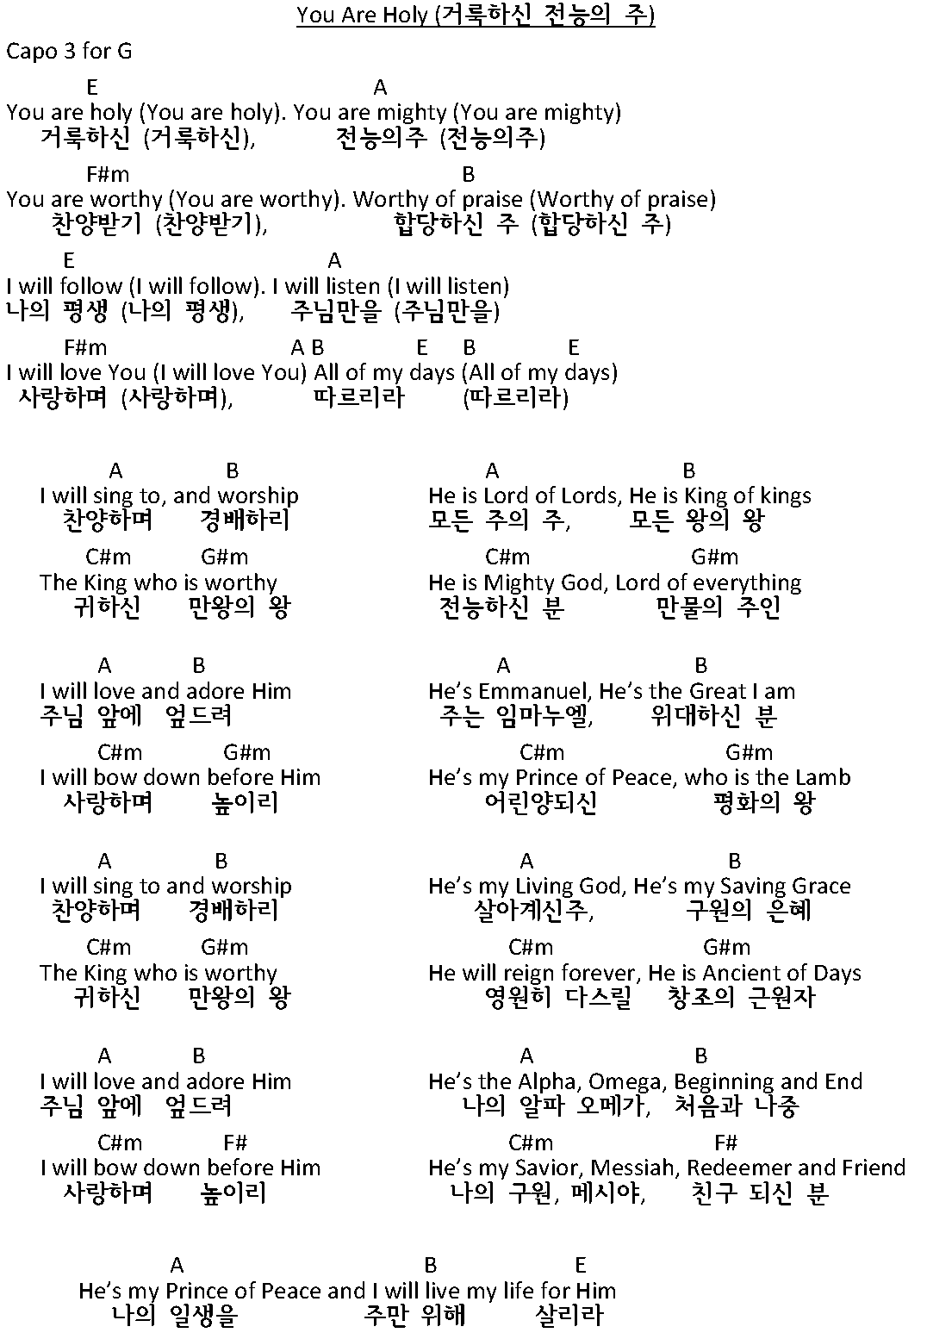
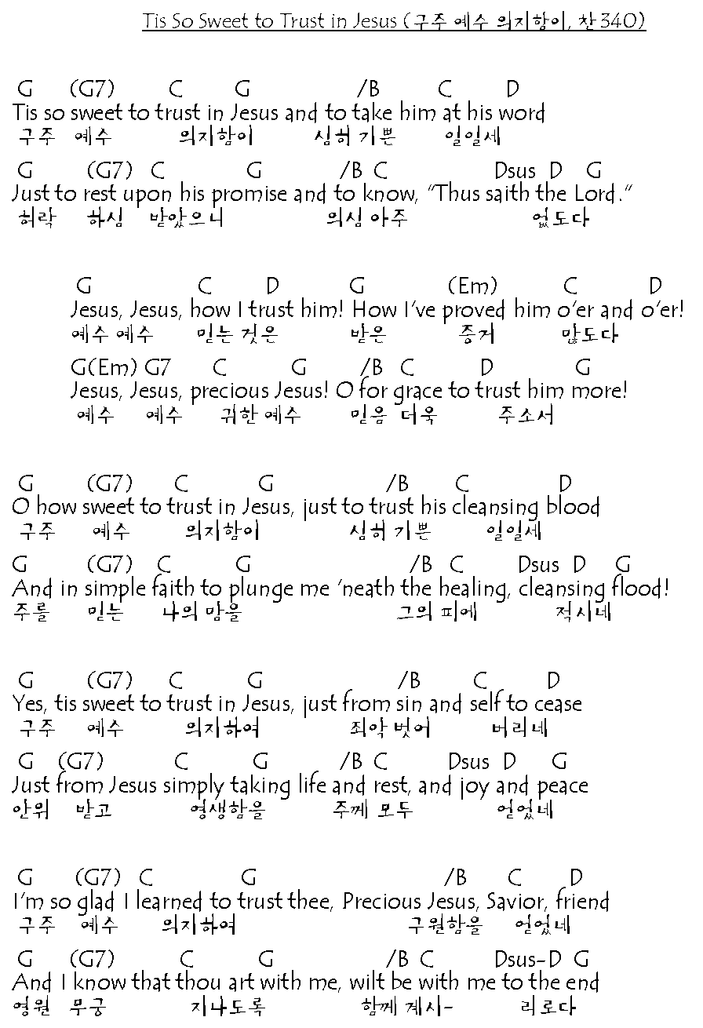

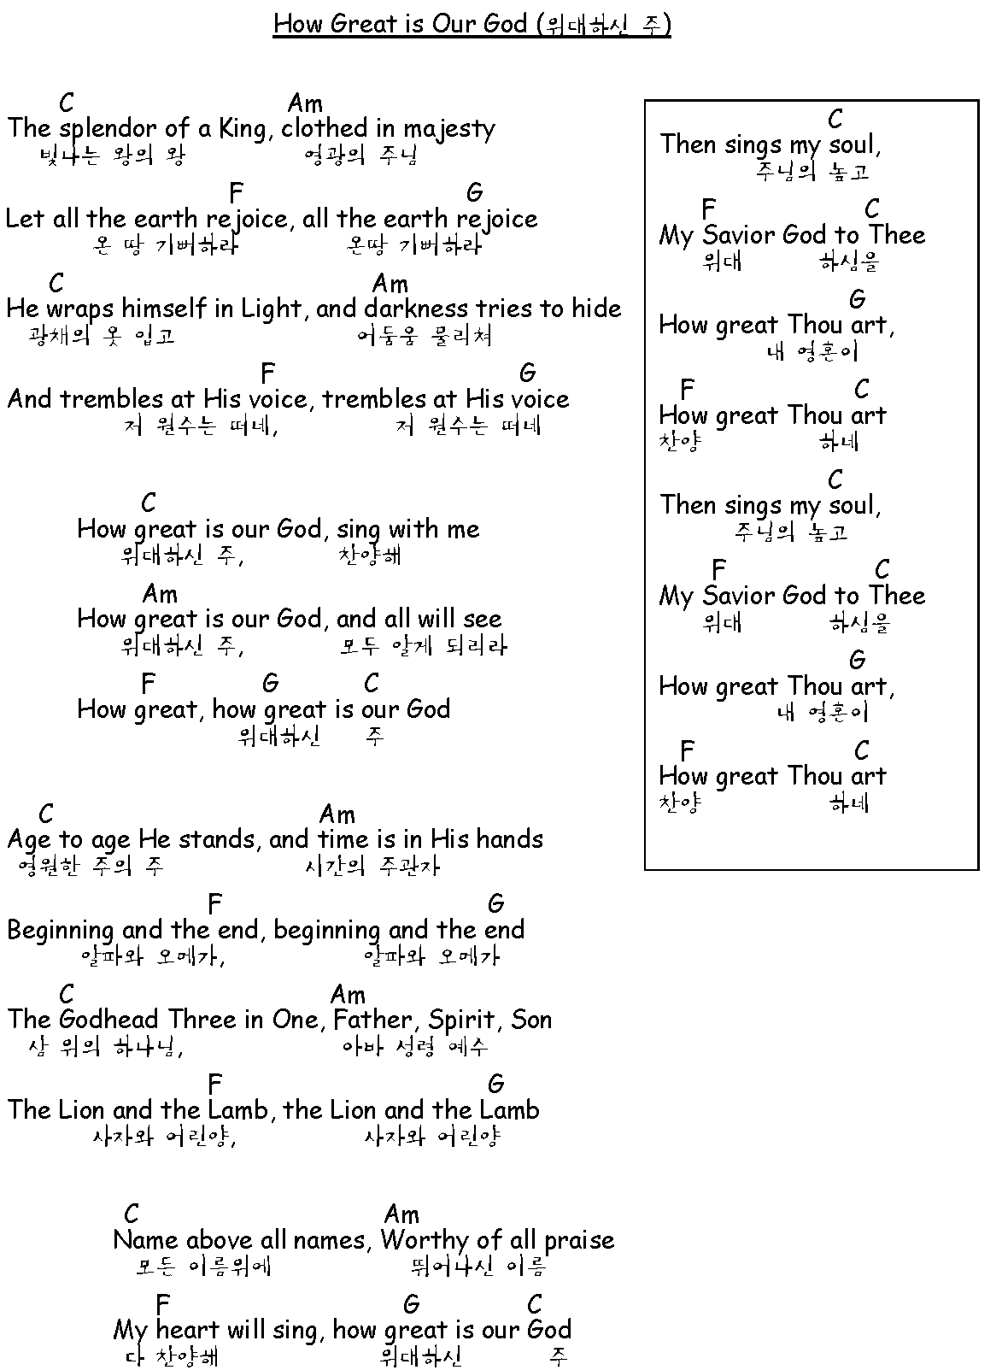
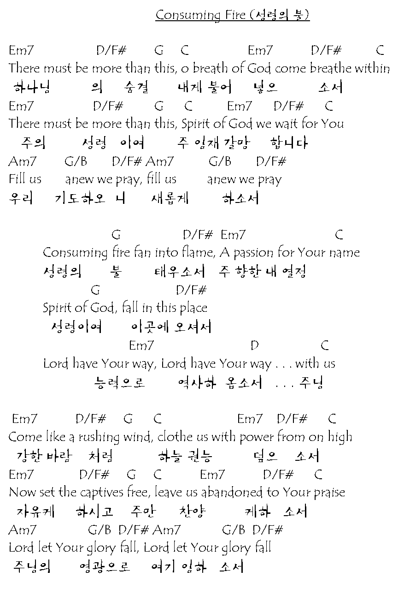
Isaiah (이사야) 53:3-6
3 He was despised and rejected— a man of sorrows, acquainted with deepest grief. We turned our backs on him and looked the other way. He was despised, and we did not care. 4 Yet it was our weaknesses he carried; it was our sorrows that weighed him down. And we thought his troubles were a punishment from God, a punishment for his own sins! 5 But he was pierced for our rebellion, crushed for our sins. He was beaten so we could be whole. He was whipped so we could be healed. 6 All of us, like sheep, have strayed away. We have left God’s paths to follow our own. Yet the Lord laid on him the sins of us all.
3그는 사람들에게 멸시와 천대를 받고 슬픔과 고통을 당하는 사람이 되었으니 사람들이 그를 외면하고 우리도 그를 귀하게 여기지 않았다. 4그는 우리의 질병을 지고 우리를 대신하여 슬픔을 당하였으나 우리는 그가 하나님의 형벌을 받아 고난을 당하는 것으로 생각하였다. 5그가 우리의 죄 때문에 찔림을 당하고 상처를 입었으니 그가 징계를 받음으로 우리가 평화를 누리게 되었고 그가 채찍에 맞음으로 우리가 고침을 받았다. 6우리는 다 길 잃은 양처럼 제각기 잘못된 길로 갔으나 여호와께서는 우리 모든 사람의 죄를 그에게 담당시키셨다.

